**AWS Task-3**

1. Create an S3 bucket with no public access and upload files to the bucket. Then, view the logs using CloudWatch for the uploaded files.

**Create S3 Bucket**

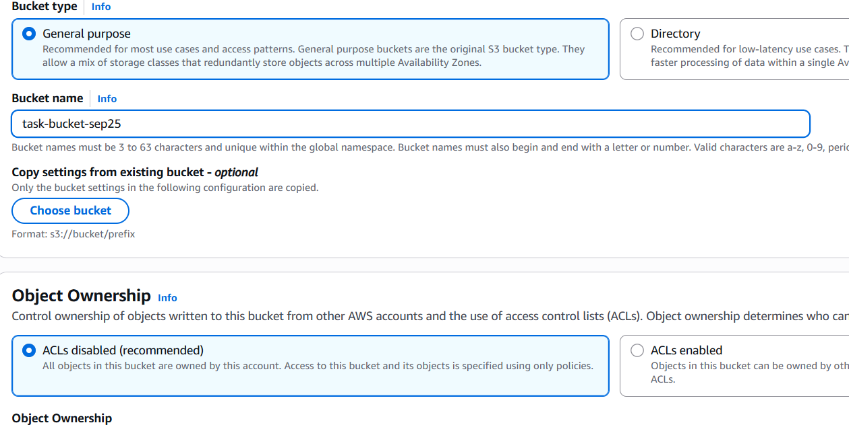

**Set no public access**

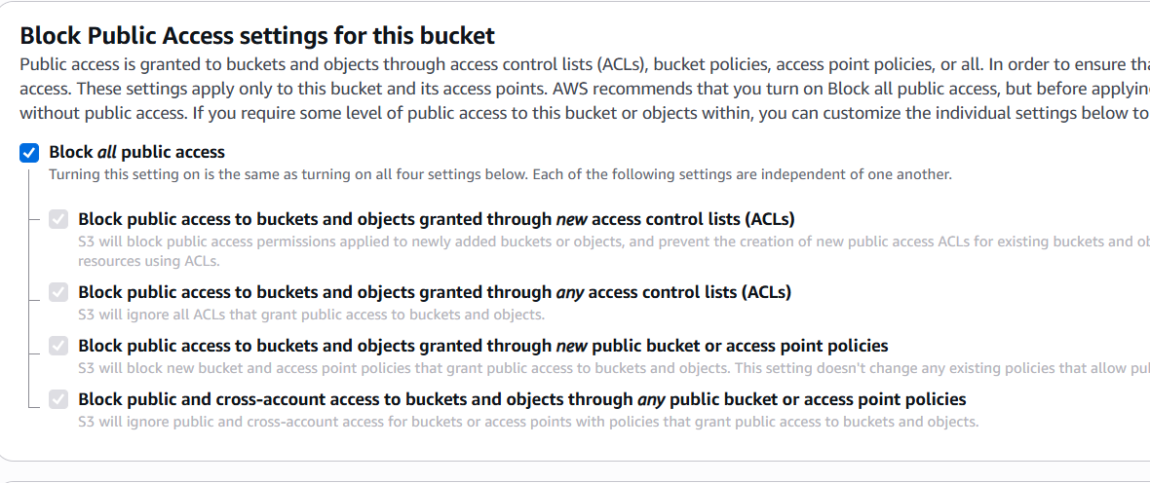

**Upload Images in S3 Bucket**

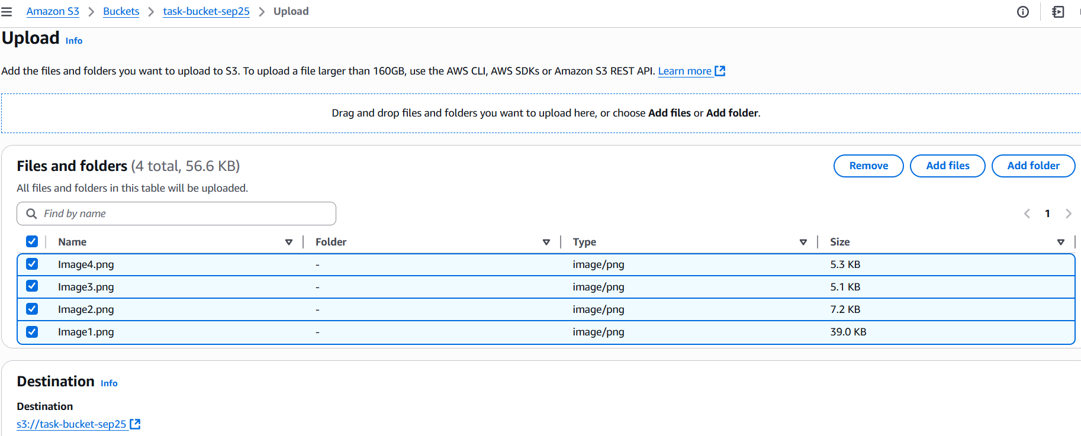

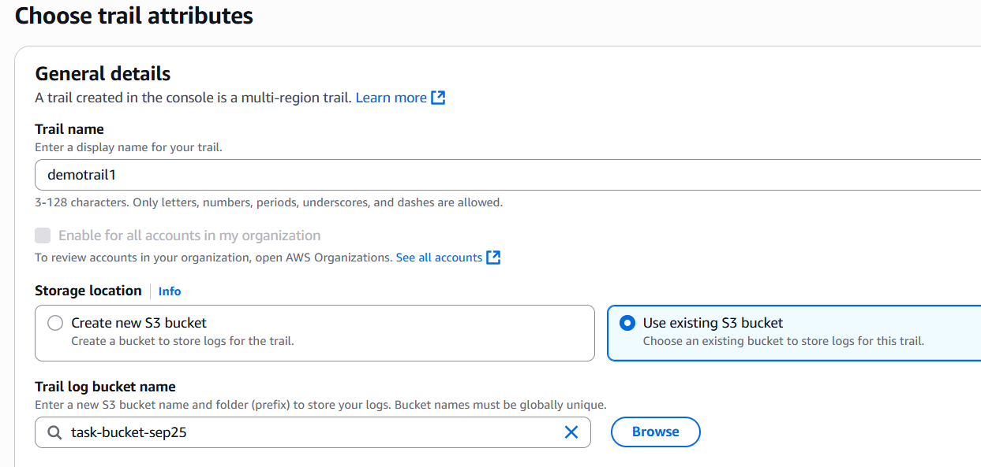

**2. Launch two EC2 instances and connect them to an application load balancer, where the output traffic from the server must be a load balancer IP address:**

**Launch two EC2 Instances**

**Instance 1:**

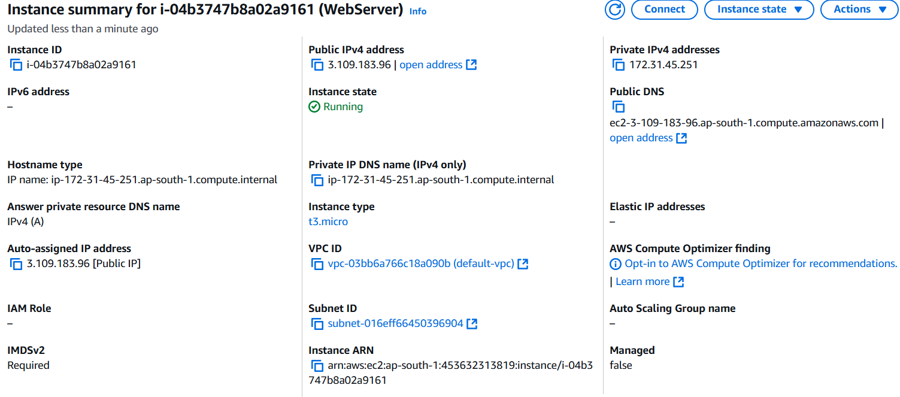

**Instance 2:**

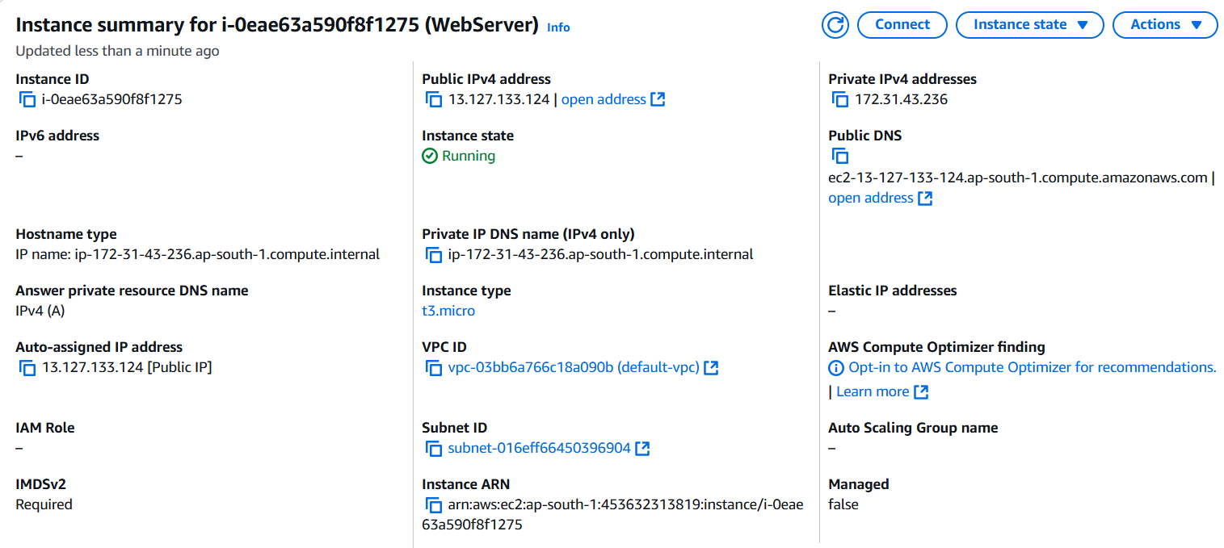

**Create Load Balancer**

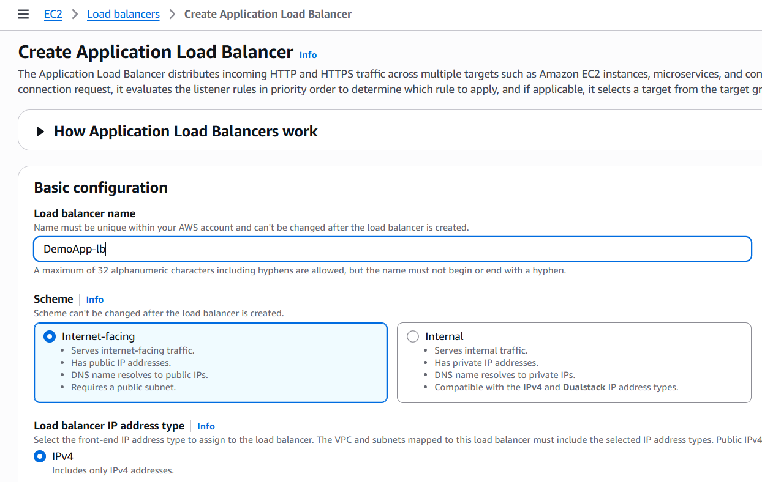

**Create Target Group for Load Balancer**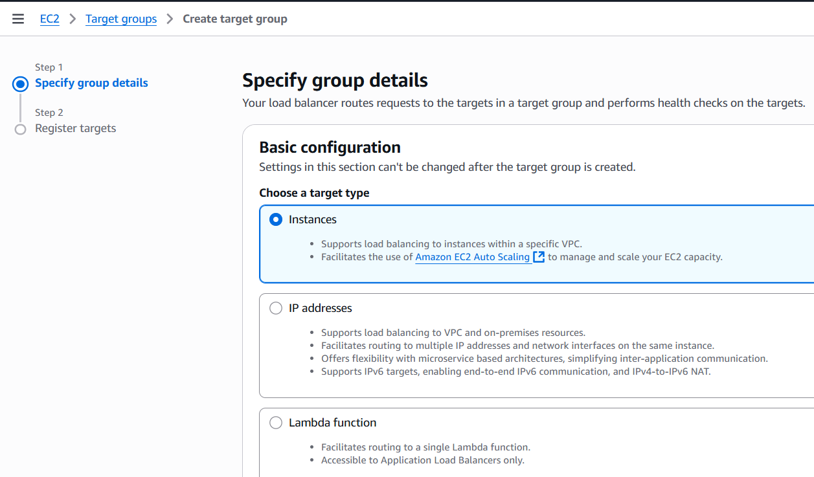

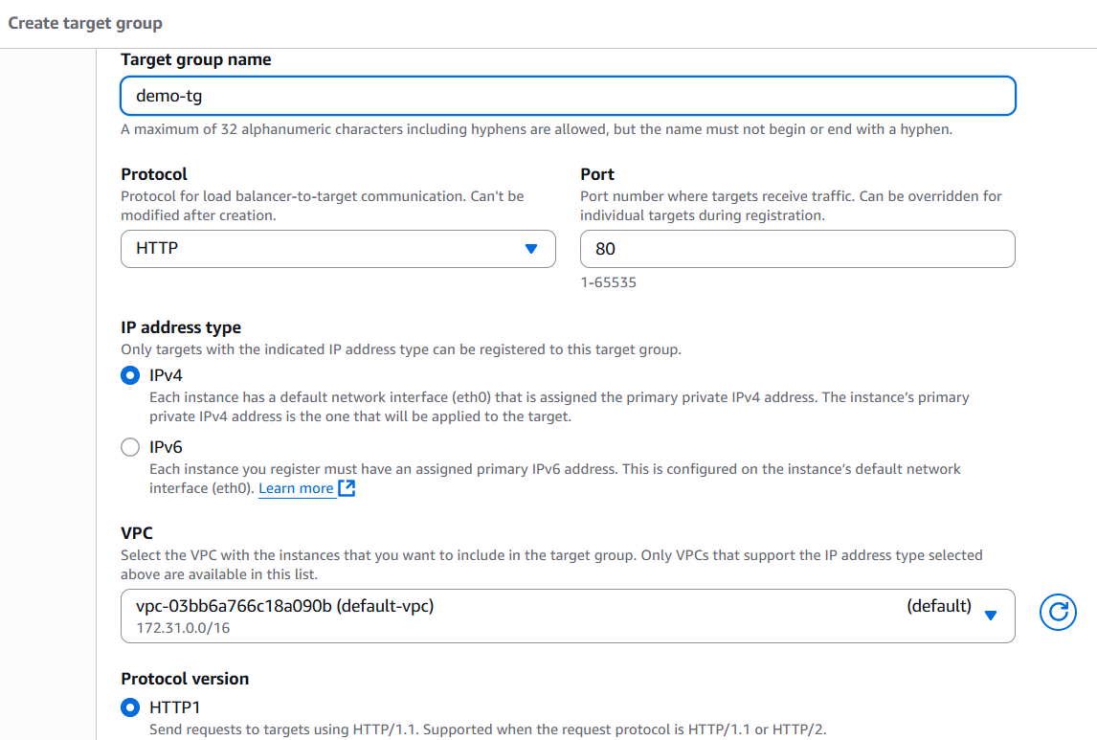

**Connect two EC2 Instances to the Application Load Balancer via a target group**

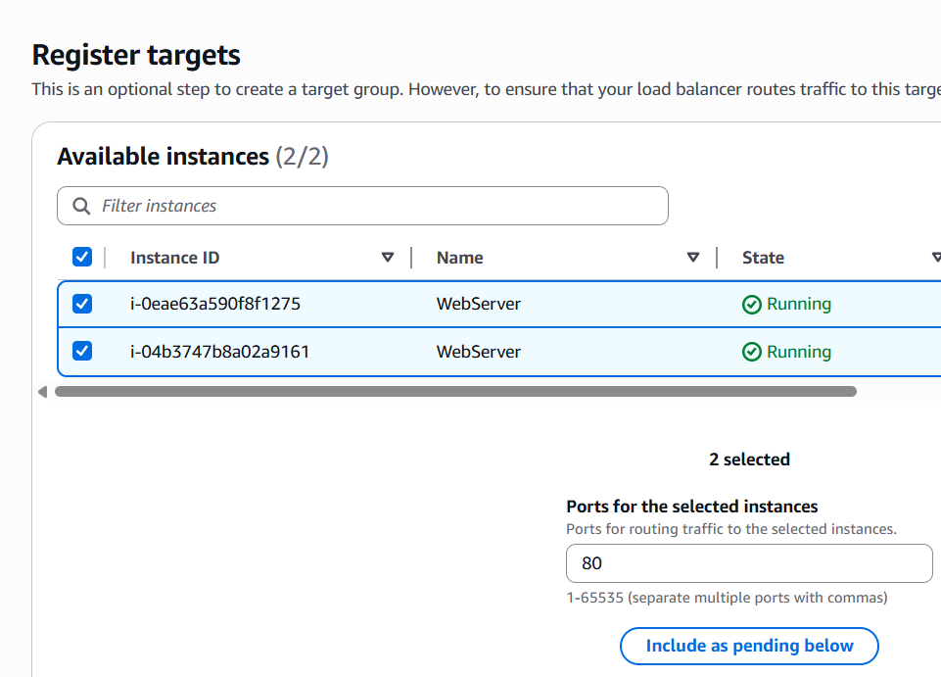

**Review of Load Balancer**

